Home
Registration Portal
Performing Arts

START - Performing Arts
IMPORTANT NOTE REGARDING REGISTERING A GROUP OF UNPUBLISHED WORKS
You may register up to 10 unpublished works on the same application, but YOU MUST SELECT the new application for a “Group of Unpublished Works.”
If you need help finding the application for a “Group of Unpublished Works,” view this image or watch this video that provides step-by-step instructions for completing this application. You can also reference these frequently asked questions for further information.
The “Standard Application” MAY NOT BE USED to register a “collection” of unpublished works. If you submit 2 or more works on the “Standard Application” the Copyright Office may register only 1 of your works and remove the remaining works from the claim. To register those works you will need to resubmit them using an appropriate application form.
×
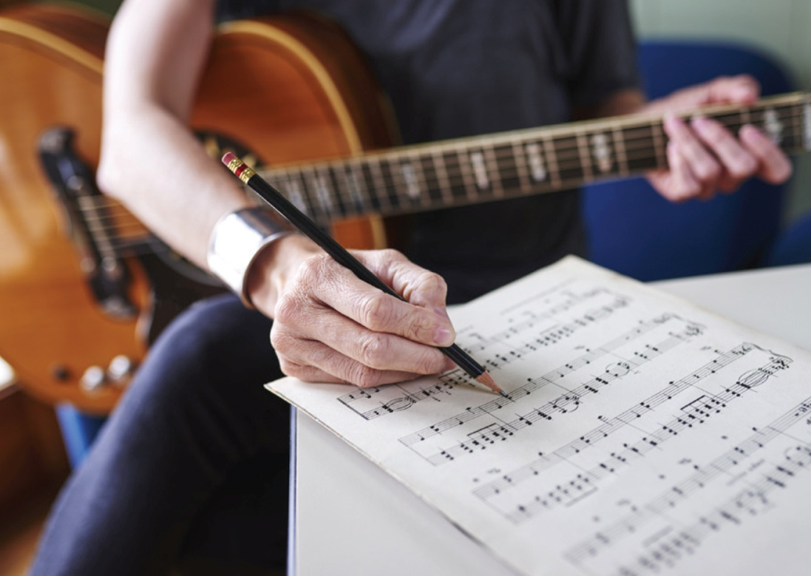

Group Registration for Unpublished Works (GRUW)
The Copyright Office has created a new group registration option for unpublished works.
Group Registration for Works on an Album of Music (GRAM)
The Copyright Office has created a new group registration option for musical works that are published on the same album.
In addition, the Office has created a separate group registration option for sound recordings, photos, artwork, and liner notes that are published on the same album.
Preview the Standard Application for a Performing Arts Work
Preview the Standard Application for a Sound Recording
Works of the performing arts are works that are intended to be performed for an audience. This category includes a wide variety of creative works, including music, lyrics, sound recordings, scripts, screenplays, choreography, motion pictures, video games, and similar types of works.
Statutory Definition
The Copyright Act states that performing a work “means to recite, render, play, dance, or act it, either directly or by means of any device or process or, in the case of a motion picture or other audiovisual work, to show its images in any sequence or to make the sounds accompanying it audible.” (17 U.S.C. § 101)
Resources
Video Tutorials
Standard Application (Video: 10m 28s)
Single Application (Video: 9m 58s)
Submit Your Work to the Copyright Office (Video: 2m 46s)
Group Registration of Unpublished Works (Video: 11m 50s)
Supplementary Registration (Video: 6m 28s)
Other Services
Paper Applications
Works of the Performing Arts (Form PA)
Sound Recordings (Form SR)
Form CON
Group Options
Unpublished Works
Musical works published on the same album
Sound recordings published on the same album
Preregistration (Restrictions Apply – Not for Majority of Applicants)
Musical Compositions
Sound Recordings
Supplementary Registration
About
Update on Deposit Requirements

